Annual General Meeting (AGM) 2022 - Lyndwood Tennis Club
March 26, 2022 @ 11AM via ZOOM

- Call to order
  - The president calls the meeting to order at 11:03AM
- Quorum
  - 8 participants in person (Sorin, Luis, Zdravko, Dan, Vlad, Ivelin, Silvia and Gaiu) and 4 participants by spouse representation (Diana, Reneta, Dana, and Branka)/family membership a total of 12 participants which meets the minimum requirement of at least 10 participants to the AGM as per article # 13 of Club’s constitution
- Reading and adoption of minutes of the previous meeting
  - Meeting minutes adapted in unanimity
- Treasurer’s Report

  - The Treasurer read the report. There were no issues or concerns raised and it was accepted unanimously.

- Businesses arising out of the Treasurer’s report:
Annual Fees for new 2022 season not changed:
Year | Junior | Adult | Family
2021 | $40 | $80 | $120
2021 | $40 | $80 | $120

Rationales:
- Strong membership growth for 2021:

  - The President presented the rational for keeping the membership as last season and there were no issues or concerns raised.
- Reports of Officers and Committees – club membership statistics
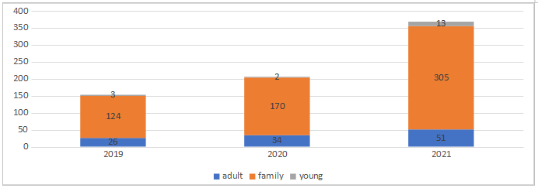
The Membership Director/the President presented the report
- New Business
  - 2022 season opening – April 2, pending city’s recommendation
    - Just informational, no voting.
    - Court Reservation system – no change.
    - Just informational, no voting – confirmed positive adoption of booking system.
    - The reservation system worked well, returning members – no change, new members system administration is a slight challenge.
    - Members will be reminded to manage their reservations considering the other members, in the sense that not to book a court and not show up.
    - Discussed pr-reserved but unused courts last season and ways to manage during new season.
    - Discussed email confirmation-reminders sent by the booking system.
    - Adopted automatic reservation cancellation if late more than 15 minutes
    - Light for court 3 issue raised – to be fixed.
  - ACE Tennis partnership for 2022 – presented by Luis.
    - Just informational, no voting.
  - Open House April 2 2022 11:30 -13:00 at Lyndwood Tennis Club courts.

- Nominations and Elections of Officers
  - President – Sorin Bejan
  - Vice President – Gaius Teodorescu
  - Treasurer – Dan Galesanu
  - Secretary – Zdravko Fidanov
  - Membership Director – Luis Palacios

    - Voted and elected unanimously.

- Adjournment
    - The AGM was adjourned at 11:40 AM

